Prevention Plus Wellness Online Course Login Instructions
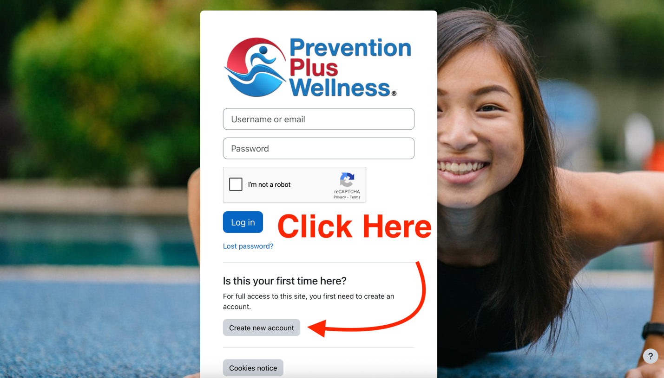
Step 1: Go to preventionpluswellnessonline.com. Click on “create new account” to sign up.

Step 2: Verify your email address (check your spam folder if you don’t receive an email in your inbox). This is what the verification email will look like.

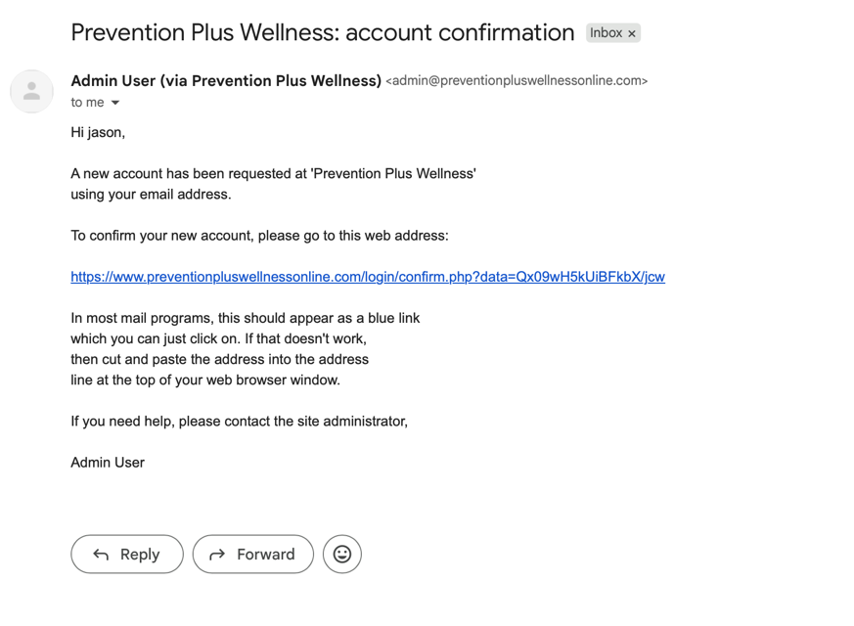

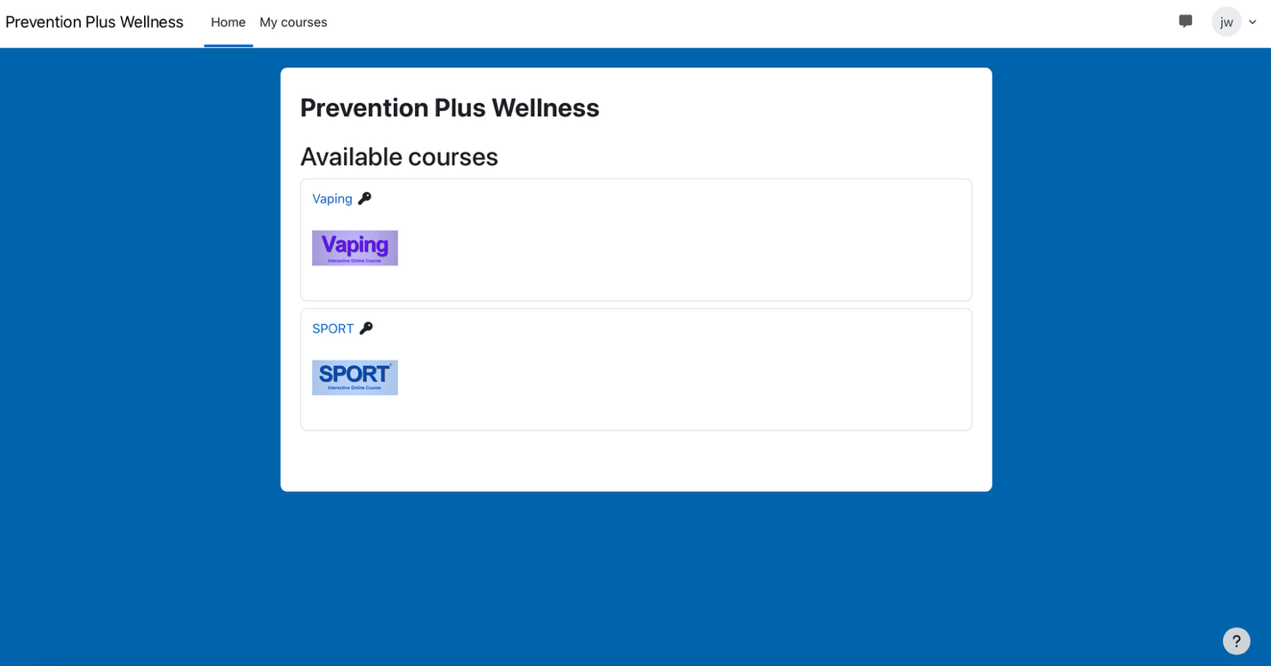
Step 3: Upon clicking the verification email link, you will arrive back at preventionpluswellnessonline.com and will see the available courses.

Step 4: Click on the course you have signed up for and you’ll see a list of enrollment options.
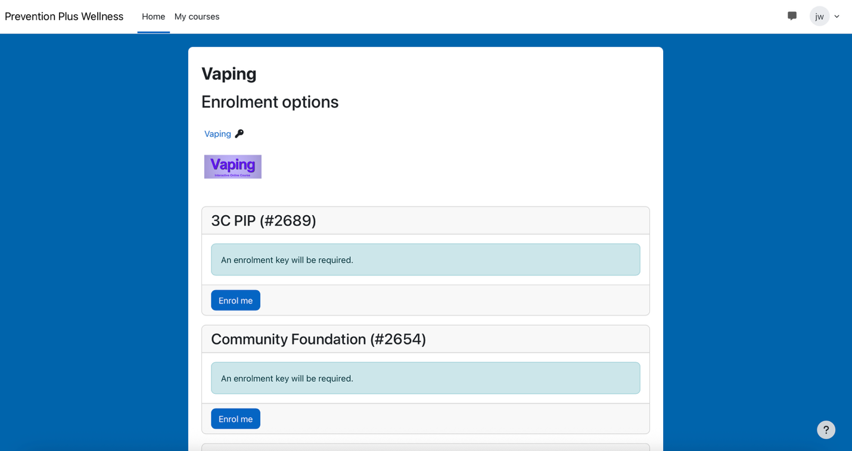

Step 5: Scroll down to your school/organization’s login option. Then click ‘enrol me’. Enter the enrollment key provided by your teacher/prevention specialist. This will unlock the course.

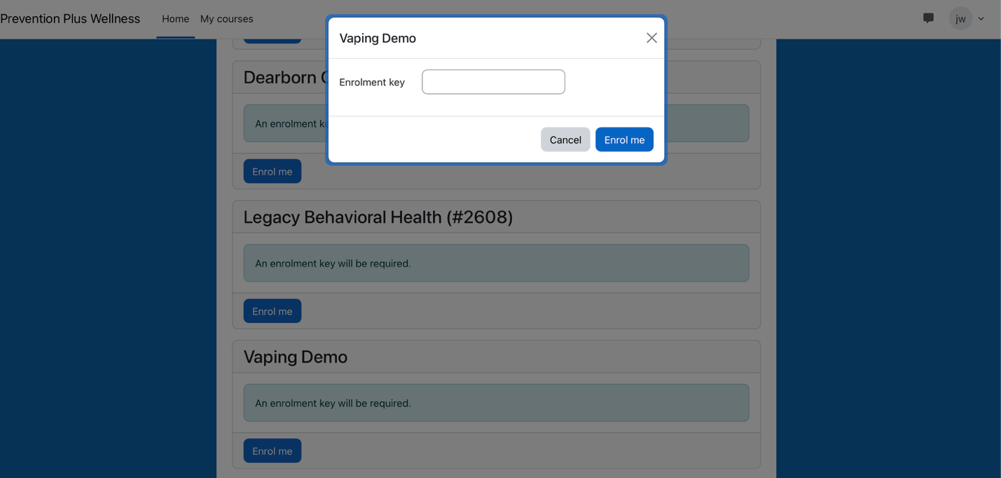

You can now begin the course! Follow the instructions on each page. You will need to complete each assignment to unlock the next assignment.

